Polarity Game Overview

1 High Level

1.1 Overview

Polarity is a 2D platformer that will focus on the mechanics of magnets to navigate through complex puzzles. You play as a magnetic character and press a button to swap between positive and negative to assist with traversing the platforms.

.

1.2 Design Goals

* Create a 2D platformer that gets progressively more difficult to the point of it being stupid-hard.
* Get magnetic physics working properly
* Have simple controls

2 Specifics

2.1 General Gameplay

* Main Character:
  + Main character is a metal character that can switch between +/- with the press of a button instantly
  + Can jump short distances but **can’t jump when stuck to a platform with opposite polarity**
* Surfaces/Platforms
  + Normal platforms are non-magnetic and are not affected by polarity
  + There are platforms that are positive and some are negative and will have a certain look to them so that the user can easily determine which polarity to be on.
  + Some platforms will be positive/negative and switch on a timer causing the user to have to switch polarity or get repelled off.
  + Moving platforms from left to right over top of lava
  + Rusty platforms that disappear after standing on them for a certain amount of time
  + Can stick to ceilings if they are low enough and you are opposite polarity
  + 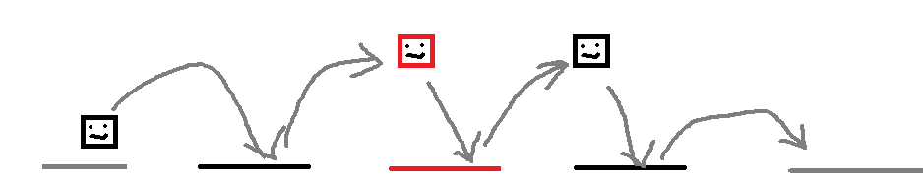Platforms with alternating polarity which cause the user to have to change their polarity mid-air (see photos below)

Moving platforms: